- Use Newton Raphson method to solve

f(x)=1-3x+1/2xe^{x}
soln.
$$f\left(x\right)=1-3x+\frac{1}{2}xe^{x}$$
$$f^{'}\left(x\right)=-3+1/2{ e}^{x}(1+x)$$
$$x_{n+1}=x_{n}-(1-3x_{n}+1/2x_{n}e^{xn}) /(-3+\frac{1}{2}{ e}^{x}\left(1+x\right) )$$
f(0)=1
x₀=0.5
$$f\left(x\right)=1-3(0.5)+\frac{1}{2}(0.5)e^{0.5}$$
$$f\left(0.5\right)=-0.08782$$
The root is in the region between 0 and 0.5
So,
$$f\left(x\right)=1-3x+\frac{1}{2}xe^{x}$$
$$f\left(x\right)=1-3(0.5)+\frac{1}{2}(0.5)e^{0.5}$$
$$f\left(0.5\right)=-0.08782$$
Also,
$$f^{'}\left(x\right)=-3+1/2{ e}^{x}(1+x)$$

$$f^{'}\left(0.5\right)=-3+1/2{ e}^{0.5}(1+0.5)$$
$$f'\left(0.5\right)=-1.76345$$
$$x_{n+1}=x_{n}-(1-3x_{n}+1/2x_{n}e^{xn}) /(-3+\frac{1}{2}{ e}^{x}\left(1+x\right) )$$
$$x_{1}=0.5-\left(-0.0878197\right)/(-1.76345 )$$
$$x_{1}=0.45020033$$
$$f\left(x_{1}\right)=0.002497$$
$$f'\left(x_{1}\right)=-1.8625887$$
$$x_{n+1}=x_{n}-(1-3x_{n}+1/2x_{n}e^{xn}) /(-3+\frac{1}{2}{ e}^{x}\left(1+x\right) )$$
$$x_{2}=0.45020033-\left(0.002497\right)/(-1.8625887)$$
$$x_{2}=0.4515409$$
$$f\left(x_{2}\right)=0.000001728$$
$$f'\left(x_{2}\right)=-1.86000996$$
$$x_{3}=0.4515409-\left(0.000001728\right)/(-1.86000996)$$
$$x_{3}=0.45154190$$
$$x_{3}-x_{2}=0.000000929$$
$$0.000000929<000001$$
S0, $x=0.451$419

The Newton Raphson Pseudo code
START

Define f(x) = 1 - 3x + (1/2)xe^x
Define f'(x) = -3 + (1/2)e^x(1+x)

Set initial guess x = 0.5
Set tolerance = 0.000001
Set maximum iterations = 100

FOR i = 1 to maximum iterations

Calculate fx = f(x)
Calculate dfx = f'(x)

Calculate x_new = x - fx/dfx

Calculate error = |x_new - x|

Display iteration, x, fx, dfx, x_new, error

If error < tolerance
Display root
STOP
End If

Set x = x_new

END FOR

END

Using The “for” loop

% Newton-Raphson Method

f = @(x) 1 - 3*x + 0.5*x*exp(x);
df = @(x) -3 + 0.5*exp(x)*(1 + x);

x = 0.5; % Initial guess
tol = 1e-6; % Tolerance
maxIter = 100;

fprintf('Iter\t x\t\t f(x)\t\t x_new\t\t Error\n');

for i = 1:maxIter

fx = f(x);
dfx = df(x);

x_new = x - fx/dfx;

error = abs(x_new - x);

fprintf('%d\t %.8f\t %.8f\t %.8f\t %.8f\n', ...
i, x, fx, x_new, error);

if error < tol
break;
end

x = x_new;
end

fprintf('\nRoot = %.8f\n', x_new);
fprintf('Number of iterations = %d\n', i);

using the ‘while’ loop

% Newton-Raphson Method using while loop

f = @(x) 1 - 3*x + 0.5*x*exp(x);
df = @(x) -3 + 0.5*exp(x)*(1 + x);

x = 0.5; % Initial guess
tol = 1e-6;
maxIter = 100;

i = 0;
error = Inf;

fprintf('Iter\t x\t\t f(x)\t\t x_new\t\t Error\n');

while error >= tol && i < maxIter

i = i + 1;

fx = f(x);
dfx = df(x);

x_new = x - fx/dfx;

error = abs(x_new - x);

fprintf('%d\t %.8f\t %.8f\t %.8f\t %.8f\n', ...
i, x, fx, x_new, error);

x = x_new;
end

fprintf('\nRoot = %.8f\n', x);
fprintf('Number of iterations = %d\n', i);

START

↓

Define f(x) and f'(x)

↓

Set x₀, tolerance,
and maximum iterations

↓

Calculate
f(x), f'(x)

↓
xnew = x - f(x)/f'(x)

↓
error = |xnew - x|
↓
error <
tol?

YES │ NO

↓

Display
root
↓ ↓

STOP x = xnew

│
└──────→ Calculate again

No.2 ;
SOLVE f(x)=x-2sinx=0 USING THE SECANT RULE
​​From $x_{n+1}=x_{n}-\frac{f\left(x_{n}\right)\left(x_{n}-x_{n-1}\right)}{f\left(x_{n}\right)-f(x_{n-1})}$
$$f\left(x\right)=x-2sinx$$
Initial values $x_{o}=1, x_{1}=2$
Iteration | x_{n-1} | x_{n} | x_{n+1}
0 | 1.000000 | 2.000000 | 1.790125
1 | 2.000000 | 1.790125 | 1.889121
2 | 1.790125 | 1.889121 | 1.895915
3 | 1.889121 | 1.895915 | 1.895493
4 | 1.895915 | 1.895493 | 1.895494
5 | 1.895493 | 1.895494 | 1.895494
Therefore;
$$x=1.895494$$
The secant pseudo code

START

Define f(x) = x - 2sin(x)

Set x0 = 1
Set x1 = 2
Set tolerance = 0.000001
Set maximum iterations = 100
Set iteration = 0

REPEAT

Calculate:
x2 = x1 - [f(x1)(x1 - x0)] / [f(x1) - f(x0)]

Calculate error:
error = |x2 - x1|

Set x0 = x1
Set x1 = x2

Increase iteration by 1

UNTIL error < tolerance OR iteration = maximum iterations

Display x1 as the root
Display number of iterations

STOP
THE FLOW CHART

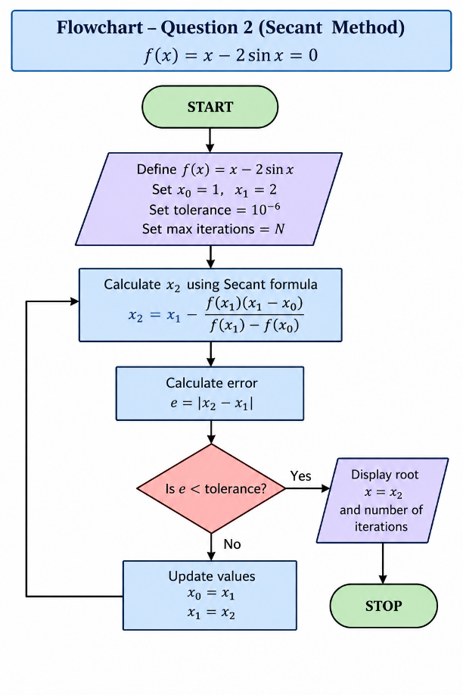
The secant MATLAB code ‘for’ loop
f = @(x) x - 2*sin(x);

x0 = 1;
x1 = 2;
tol = 1e-6;
maxIter = 100;

for i = 1:maxIter
x2 = x1 - f(x1)*(x1-x0)/(f(x1)-f(x0));
error = abs(x2-x1);

if error < tol
break
end

x0 = x1;
x1 = x2;
end

fprintf('Root = %.8f\n',x2);

The secant MATLAB code ‘while’ loop
f = @(x) x - 2*sin(x);

x0 = 1;
x1 = 2;
tol = 1e-6;
error = Inf;
i = 0;

while error >= tol
i = i + 1;

x2 = x1 - f(x1)*(x1-x0)/(f(x1)-f(x0));
error = abs(x2-x1);

x0 = x1;
x1 = x2;
end

fprintf('Root = %.8f\n',x1);

$thus, x=1.89549427$

NO.3
Use fourth order Runge Kutta method to solve the algorithm with step size h=0.2 to solve the initial value problem $\frac{dy}{dx}+2y=sin3x$ with y(0)=1
With $y\left(0\right)=1$
And h=0.2,
$$0≤x≤2.4$$
$$\frac{dy}{dx}+2y=sin3x$$
Therefore $f\left(x,y\right)=sin3x-2y$
For the fourth order Runge Kutta method,
$$k_{1}=hf\left(x_{n},y_{n}\right)$$
$$k_{2}=hf(x_{n}+\frac{h}{2}, y_{n}+\frac{k_{1}}{2})$$
$$k_{3}=hf(x_{n}+\frac{h}{2}, y_{n}+\frac{k_{2}}{2})$$
$$k_{2}=hf(x_{n}+h, y_{n}+k_{3})$$
Then, $y_{n+1}=y_{n}+\frac{1}{6}(k_{1}+2k_{2}+2k_{3}+2k_{4})$
$$h=0.2$$
x | y
0.0 | 1.000000
0.2 | 0.721532
0.4 | 0.612924
0.6 | 0.573054
0.8 | 0.522623
1.0 | 0.416748
1.2 | 0.250514
1.4 | 0.053902
1.6 | -0.123237
1.8 | -0.231648
2.0 | -0.241923
2.2 | -0.156146
2.4 | -0.008087

S0, $y\left(2.4\right)≈0.008087$

The fourth order Runge Kutta pseudo code/ Flow chart
Pseudocode: Fourth-Order Runge-Kutta Method

START

Define f(x,y) = sin(3x) - 2y

Set x = 0
Set y = 1
Set h = 0.2
Set final_x = 2.4

WHILE x < final_x

Calculate:
k1 = h*f(x,y)

k2 = h*f(x + h/2, y + k1/2)

k3 = h*f(x + h/2, y + k2/2)

k4 = h*f(x + h, y + k3)

Calculate new y:
y = y + (k1 + 2k2 + 2k3 + k4)/6

Update x:
x = x + h

Display x and y

END WHILE

Display final value y(2.4)

STOP

FLOWCHART
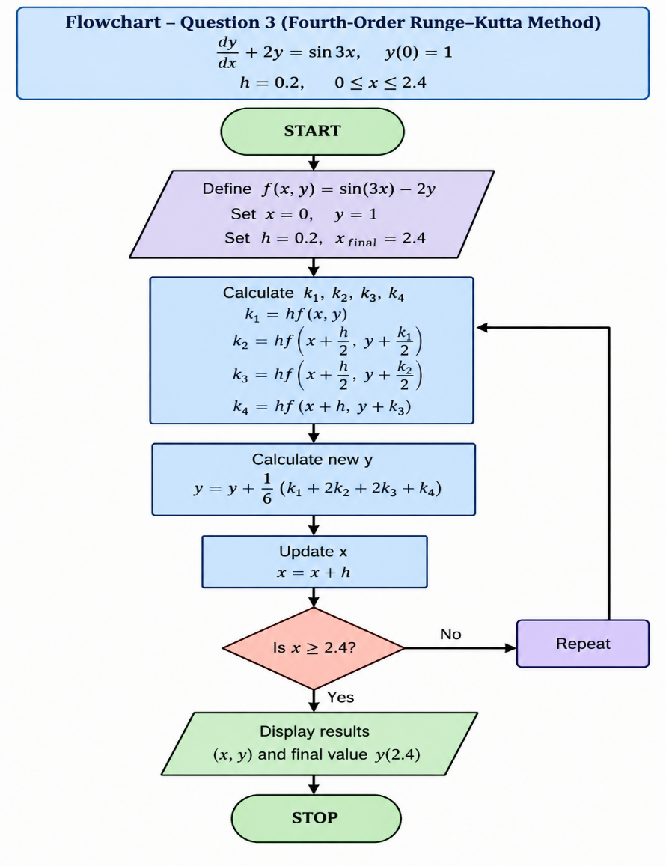

The fourth order Runge Kutta MATLAB “for” loop
h = 0.2;
x = 0;
y = 1;

n = round((2.4-0)/h);

for i = 1:n

f = @(x,y) sin(3*x) - 2*y;

k1 = h*f(x,y);
k2 = h*f(x+h/2,y+k1/2);
k3 = h*f(x+h/2,y+k2/2);
k4 = h*f(x+h,y+k3);

y = y + (k1+2*k2+2*k3+k4)/6;
x = x + h;

fprintf('x = %.1f, y = %.6f\n',x,y);
end

The fourth order Runge Kutta MATLAB code “while” loop
h = 0.2;
x = 0;
y = 1;

while x < 2.4

f = @(x,y) sin(3*x) - 2*y;

k1 = h*f(x,y);
k2 = h*f(x+h/2,y+k1/2);
k3 = h*f(x+h/2,y+k2/2);
k4 = h*f(x+h,y+k3);

y = y + (k1+2*k2+2*k3+k4)/6;
x = x + h;

fprintf('x = %.1f, y = %.6f\n',x,y);
end

